DASH AWS EC2 Access Guide

Input Guide
This section outlines the input parameters required for provisioning AWS EC2 using the DASH portal. Each parameter includes a description, available options, usage guidance, and notes on valid combinations when applicable.
Input Parameter | Description | Values Provided | Value Guidance | Valid Combinations
hostname | A unique name to identify the ec2 instance. | Any alphanumeric string. | Use clear naming conventions for easier resource management. | N/A
os_template | Pre-configured base operating system image (Amazon Machine Image) used for provisioning the EC2 instance. | ubuntu-2204-lts, ubuntu-2004-lts,ubuntu-2404-lts,rhel-9, rhel-8, windows-2019, windows-2022, centos, amazon-linux, amazon-linux-2023. | Choose an OS required for your workload. | N/A
instance_type | The size and configuration of the EC2 instance, which defines the amount of vCPUs, memory, and networking performance allocated. | t2.nano, t2.micro, t2.small, t2.medium, t2.large, t2.xlarge, t2.2xlarge, a1.metal, c4.large, c4.xlarge | Choose based on workload requirements (vCPU, memory). | N/A
region | The AWS Region in which the EC2 instance will be deployed. | us-east-1, us-west-2, eu-west-1, ap-south-1, ca-central-1, eu-west-2, ap-southeast-1, sa-east-1 | Choose the region that is geographically closest to your end users or integrated services to minimize latency and improve performance. | N/A
service_name | The name of the service that has to be installed in the EC2. | docker, minio, mongodb, nfs, nginx, postgres, kubernetes, llavallm, none | Choose based on the role the instance will serve (eg: Docker for container hosts, Postgres for DB) | N/A
owner | The team or individual responsible for provisioning, managing, and maintaining the resource. | Specify the team name or individual responsible for maintaining the instance. | Provide correct team/individual name. | N/A
application | Associated service or application name for the resource. | Enter the associated service name linked to the instance. | Provide a service name linked to the instance. | N/A
project | Project or initiative name linked to the resource. | Indicate the project or initiative name related to the resource. | Provide the project name related to the resource. | N/A
deployment | The target environment (e.g., development, testing, prod) where the resource will be provisioned. | Define the deployment environment name (e.g., dev, test, prod) | Choose the environment where the instance has to be deployed. | N/A
Services expire after 30 days. Create this service now, or schedule for a later date? | EC2 will be deleted 30 days after creation, or it can be scheduled to be created at a later date. | Create Now (or)  Schedule for Later | Choose based on EC2 requirements. | N/A

Sample Input Selection:
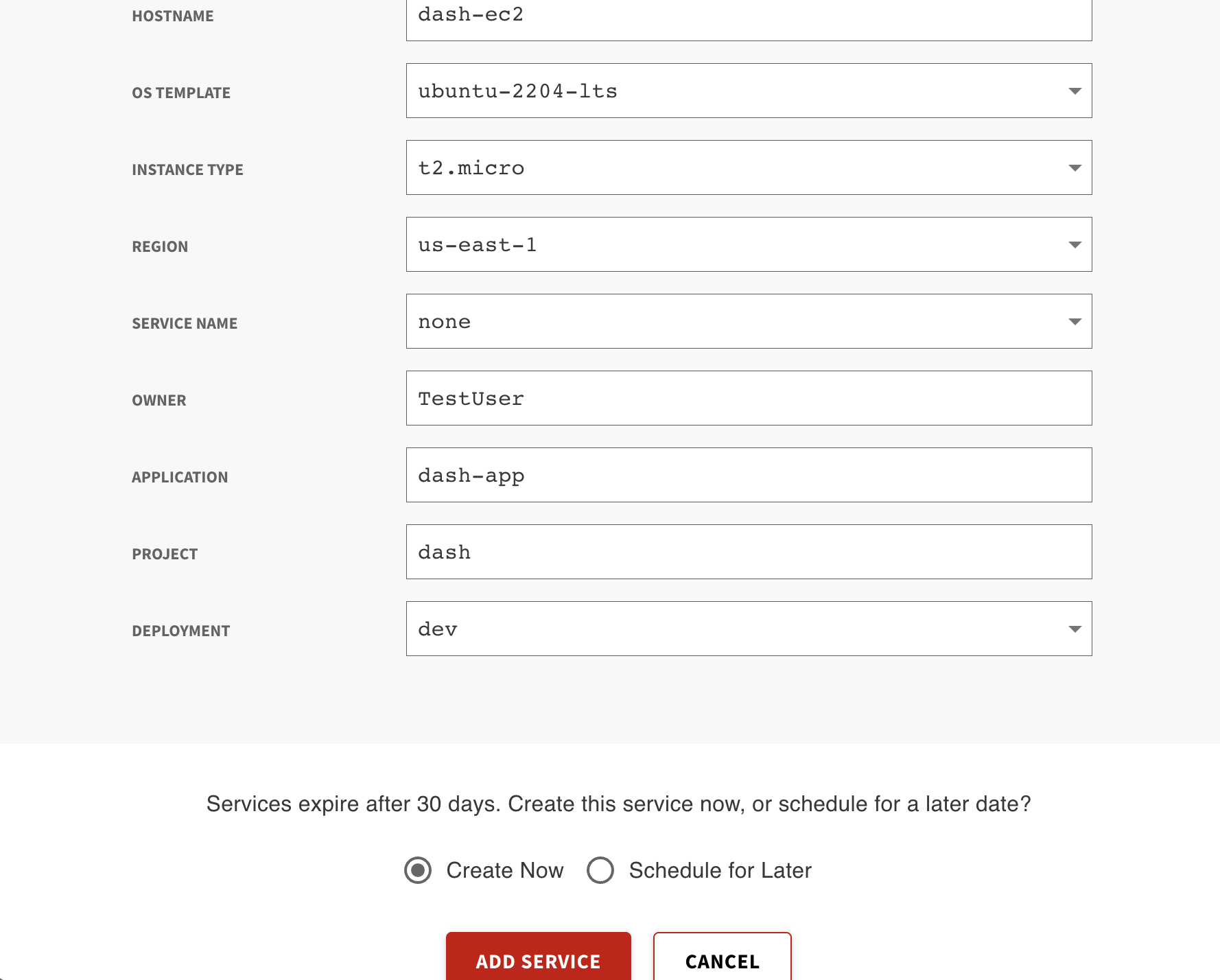

Output Guide
This section outlines the output values generated after AWS EC2 provisioning through the DASH Portal. These outputs can be used to access, manage, and connect to your virtual machine.
Outputs | Description | Example Value
host_name | A unique name to identify the EC2. | dash-dash-ec2-j0R2
instance_id | A unique id to identify the instance. | i-03c1ab84935f81532
private_ip | Private IP of the instance. | 10.0.1.50
private_key | Private Key to login to the instance. | <RSA PRIVATE KEY>
public_ip | Public IP of the instance. | 98.87.6.47
ssh_password | Password to SSH into the EC2. | Tdzg00e9
ssh_username | Username to login to the EC2. | dash
vm_name | Instance name used for easy identification and management. | dash-ec2

Steps to SSH to EC2 instance:
1. SSH into the Elastic Compute Cloud(Linux-based OS):
Use the following commands to connect to and manage your AWS EC2. Replace placeholder values like <public_ip_address>, <ssh_username>, etc., with the actual outputs provided during provisioning.
Command: ssh <ssh_username>@<public_ip_address>
When prompted, enter the value of ssh_password to log in to the machine.
Example: ssh dash@98.87.6.47
2. RDP into the Virtual Machine (Windows-based OS):
1. Open Remote Desktop Connection (mstsc on Windows).
2. Enter the Public IP Address (e.g., 98.87.6.47).
3. Use the username (ssh_username) and password (ssh_password) from the outputs.

